Sikuli Fixes:

- Change the System.setProperty from true to false
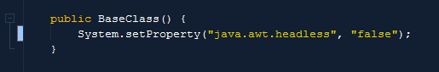
2. Instantiate the Sikuli driver in your TestClass.
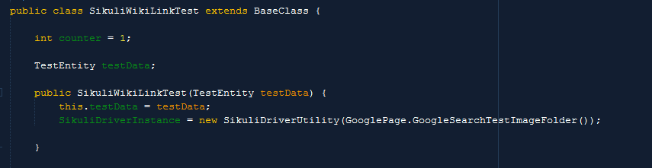
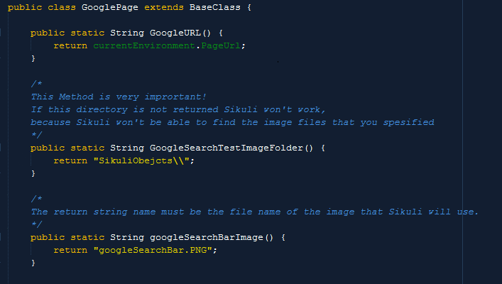
3. Add a method that returns the path to the folder where you store the images for the Sikuli tests.
4. Instead of having a method that returns an ID or class name, it returns the name of the element image file, that you want Sikuli to use.
5. Place the Sikuli images folder in the root of the project since it fails if the path gets to long. The file extension must be in capital letters.

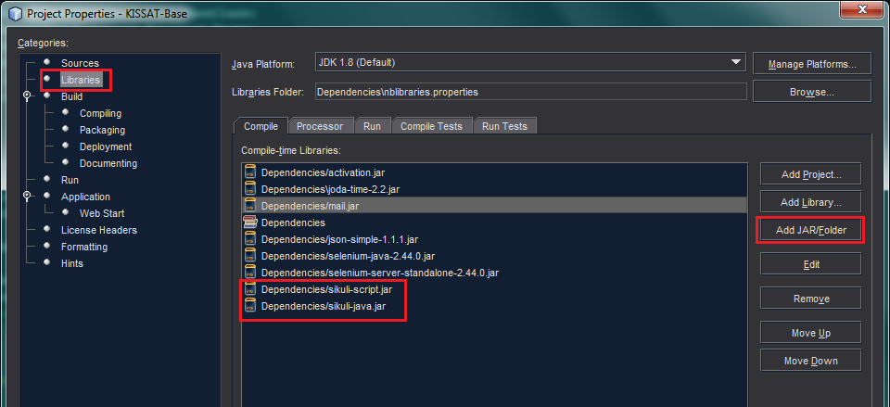
6. Make sure you have the sikuli-script.jar and the sikuli-script.jar file in your dependencies folder and that it is added to your project.
7. Make sure that Sikuli is installed on the testing machine.

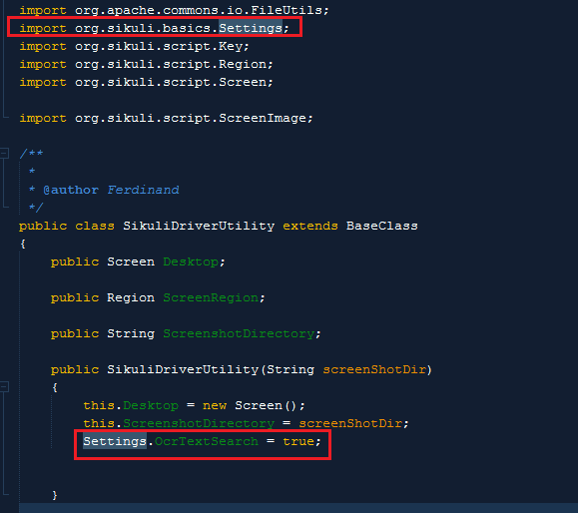
8. Add “Settings.OcrTextSearch = true;” to constructor method. As well add the import:
“import org.sikuli.basics.Settings;”

9. If your testPack isn’t being read.
-Make sure that it’s not currently opened in a Excel program.
-If the problem persists open the file in your Excel program and save the file as a new separate file with the specific format that it needs to be. Sometimes if the original file was a Microsoft created file the file
becomes changed slightly modified.

Troubleshooting:
- If Sikuli does not auto install, follow the manual install method explained below.
- If the Sikuli script does not function as expected, make sure that the resolution is the same as what the screenshots were taken.
- Install Sikuli on your testing machine:
https://launchpad.net/sikuli/sikulix/1.0.1/+download/sikuli-setup.jar

Steps to work with Sikuli - Java

Step #1 - Download the jar file Sikuli-setup.jar

Step #2 - Place the Jar file in a new folder (say D:\Sikuli)

Step #3 - Run the Jar - Two files will be created automatically

RunSetup.cmd
Log File
Step #4 - Run the runSetup.cmd file and follow instructions. Click OK --> Select 4th Option from the Form

ONLY If Setup Fails:
Setp #5 - Set Up Fails (Saying Download Failed)

Step #6 - Now Download [Sikuli-1.0.1-3 - https://launchpad.net/raiman/+download] patch file [(zip file) - https://launchpadlibrarian.net/156273987/Sukuli-1.0.1-Offline-Setup-Java-option3-option4.zip]

Step #7 - Copy the Sikuli-java.jar to the (say D:\Sikuli\Downloads)

Step #8 - Re run the runSetup.cmd and proceed.

-----
Do this after installation:
Step #9 - Sikuli-java.jar file is generated. Add this file to the java build path (in IDE)
Step#10 - Reboot computer.

More details can be found at this [link - https://answers.launchpad.net/sikuli/+question/234720]

